Ryan Harty

Data Management

Homework 3

1.

For percentage change, I subtracted the profits from 2013 by profits from 2012 and divided by the profits from 2012 to get the change in percentage. I then got the five area codes with the highest declining profits.

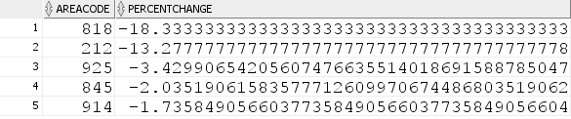

2.

I divided marketing by sales to get how the percent of marketing expense of sales. I then grouped by state and year and fetched the top ten results, two years for each 5 states.

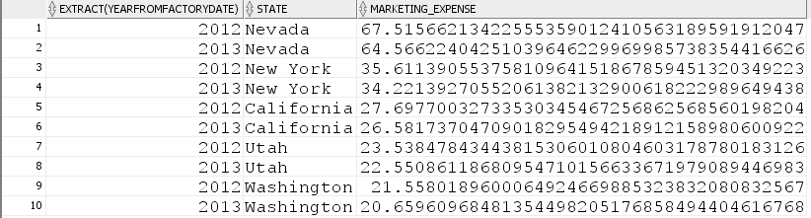

3.

I set a filter to only look at Nevada, New York, California, Utah and Washington. To get the percent of marketing expenses relative to other expenses I divided marketing by total expenses. I then look at the 10 area codes within those five states that had the highest marketing expenses relative to other expenses.

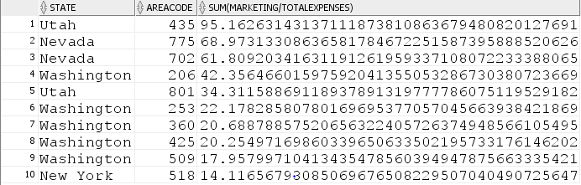

4.

I first started by making a view that showed the sum of profits in 2013 minus the sum of profits in 2012. I grouped those by market and by product. I then created separate views that returned the top value for each market and its corresponding product and the total change. To display all of them together, I used a union.

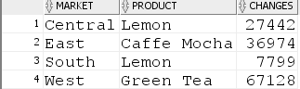

5.

I created a view that displayed states and area code, to join on factcoffee. I found that in year 2012 there were no states that exceeded budgeted profits. But there were states that exceed budgeted sales compared to sales.

